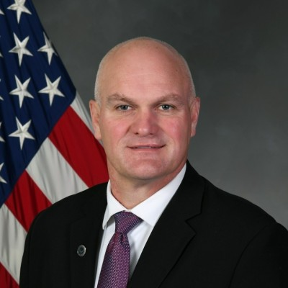
Craig L Rees, Sr.
Director, AF Digital Campaign, HQ Air Force Material Command, Engineering Directorate

Mr. Rees coordinates effort to move the activities of the Air Force enterprise, government and industry to modern digital capabilities and processes. The desired end state is a collaborative, integrated digital environment that guides, orchestrates, and delivers the means for each individual across the enterprise to access the data, functions and elements needed to do his or her job in a purely digital manner.

Mr. Rees spent twenty plus years working for small and fortune 500 enterprise software companies. Most recently Craig was a principle and VP for NLign Analytics. Mr. Rees is an entrepreneur having owned and sold various businesses. He has served on various Boards including the Board of Trustees at Utah State University. He holds a BA from Utah State University, an MBA from Portland State University, as well as a graduate certificate in Organizational Behavior from the Harvard Extension School.

